***+ANUDIP FOUNDATION***

A Project Report on

**ONLINE LEAVE MANAGEMENT SYSTEM**

By

Batch: ANP-D0453

Student ID: AF0477050

Name: Vaishnavi Chandode

**Under the Guidance of**

Mrs. Rajshri Chandrabhan Thete

ONLINE LEAVE MANAGEMENT SYSTEM

Introducing our Java-based Leave Management System (LMS):

Seamlessly manage employee leave requests, approvals, and records with our intuitive Online Leave Management System. From tracking leave balances and generating detailed reports to ensuring transparent communication between employees and HR, our OLMS streamlines the entire leave workflow—saving time, reducing errors, and enhancing organizational efficiency.

**ENTITIES:**

**❖ Admin  
❖ Company  
❖ Department  
❖ Employee  
❖ Leave  
❖ Report**

**ATTRIBUTES OF ENTITIES:**

**1. Admin**

**Attributes:**● admin_ID (Primary Key)  
● admin_name  
● admin_email  
● admin_pass

**2. Company**

**Attributes:**● comp_ID (Primary Key)  
● com_name

**3. Department**

**Attributes:**● Dep_ID (Primary Key)  
● Dep_name  
● comp_ID (Foreign Key)  
● admin_ID (Foreign Key)

**4. Employee**

**Attributes:**● emp_ID (Primary Key)  
● emp_name  
● emp_email  
● emp_pass  
● comp_ID (Foreign Key)  
● admin_ID (Foreign Key)  
● Dep_ID (Foreign Key)

**5. Leave**

**Attributes:  
●** lv_ID (Primary Key)  
● leave_type  
● start_date  
● end_date  
● leave_status  
● emp_ID (Foreign Key)  
● admin_ID (Foreign Key)

**6. Report**

**Attributes:**● Report_ID (Primary Key)  
● emp_ID (Foreign Key)  
● lv_ID (Foreign Key)  
● leave_type  
● total_leaves  
● remaining_leaves

**ENTITY RELATIONSHIP DIAGRAM - ONLINE LEAVE MANAGEMENT SYSTEM**

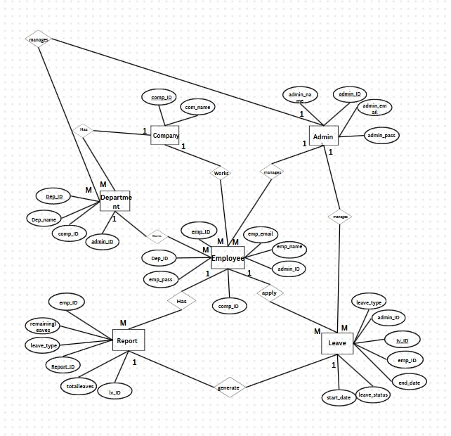

**CONCLUSION:**

In summary, the Online Leave Management System offers a robust and efficient solution for streamlining the leave application and approval process within an organization. By digitizing and automating tasks such as leave requests, tracking remaining leaves, generating reports, and managing employee records, the system enhances administrative productivity and reduces the scope for manual errors. It fosters seamless communication between employees, departments, and administrators, ensuring transparency and timely approvals. The centralized access to leave data empowers HR personnel and management to make informed decisions, maintain workforce balance, and uphold organizational policies. Overall, this system plays a critical role in optimizing human resource operations, improving employee satisfaction, and supporting a structured and well-regulated leave management process.

**DATABASE CREATION QUERY:**

**-- Admin Table**

**CREATE TABLE Admin (**

**adminId VARCHAR(255) PRIMARY KEY,**

**adminPass VARCHAR(255)**

**);**

**-- Query OK, 1 row affected (0.01 sec)**

**-- Company Table**

**CREATE TABLE Company (**

**companyId INT PRIMARY KEY,**

**companyName VARCHAR(255) NOT NULL UNIQUE**

**);**

**-- Query OK, 0 rows affected (0.02 sec)**

**-- Department Table**

**CREATE TABLE Department (**

**deptId VARCHAR(255) PRIMARY KEY,**

**deptName VARCHAR(255)**

**);**

**-- Query OK, 0 rows affected (0.01 sec)**

**-- Employee Table**

**CREATE TABLE Employee (**

**empId VARCHAR(255) PRIMARY KEY,**

**empName VARCHAR(255),**

**empEmail VARCHAR(255),**

**empPass VARCHAR(255),**

**departmentName VARCHAR(255),**

**companyName VARCHAR(255)**

**);**

**-- Query OK, 0 rows affected (0.02 sec)**

**-- LeaveTable**

**CREATE TABLE LeaveTable (**

**leaveId VARCHAR(255) PRIMARY KEY,**

**empId VARCHAR(255),**

**startDate VARCHAR(255),**

**endDate VARCHAR(255),**

**leaveType VARCHAR(255),**

**totalDays INT,**

**leaveStatus VARCHAR(255),**

**FOREIGN KEY (empId) REFERENCES Employee(empId)**

**);**

**-- Query OK, 0 rows affected (0.03 sec)**

**-- Report Table**

**CREATE TABLE Report (**

**reportId VARCHAR(255) PRIMARY KEY,**

**empName VARCHAR(255),**

**leaveType VARCHAR(255),**

**startDate VARCHAR(255),**

**endDate VARCHAR(255),**

**totalDays INT,**

**status VARCHAR(255),**

**remark VARCHAR(255),**

**generatedDate DATE**

**);**

**-- Query OK, 0 rows affected (0.03 sec)**

**+----------------+**

**| Tables_in_db |**

**+----------------+**

**| admin |**

**| company |**

**| department |**

**| employee |**

**| leavetable |**

**| report |**

**+----------------+**